UNIT 1 SOME BASIC ALGEBRA

# Constants, Variables, and Expressions

Constants and variables, at least one of these objects appear in every mathematical expression one can imagine. Let’s get a sense of just what they are.

A **VARIABLE** is a quantity that has a capacity for change in a particular context.

A **CONSTANT** is a quantity that has no capacity for change in a particular context.

Let’s put both in the context of hiring a programmer to write a program that performs some particular task. Suppose there are three programmers, *A*, *B*, and *C*, we are considering.

**Programmer A charges a flat fee of $25,000 for writing the program.**

Programmer *A*’s fee is constant. In this context, the fee has no capacity for change. The fee is $25,000, no more, no less. Outside this context, maybe writing a less complicated program, the flat fee may be less than $25,000.

**Programmer B charges $100/hour for writing the program.**

Programmer *B‘s* fee is variable. In this context, the fee has the capacity for change. The total fee varies with the amount of time taken to write the program.

**Programmer C charges a flat fee of $15,000 and $100/whole hour (1, 2, 3, …, 50) for writing the program.**

Programmer *C*’s fee is variable since the total fee varies since it has the capacity for change. The fee varies with the amount of time taken to write the program. Programmer *C*'s fee structure comprises both a constant, the flat fee of $15,000, and a variable, the $100/ whole hour. But because it contains a variable, the entire quantity is variable.

## A BIT MORE DETAIL

**CONSTANTS** are represented with numerals (1, 2, 3, …) and, in special cases, letters or symbols. The constant pi is represented with the Greek letter $π$, where $π$ is the non-repeating and non-terminating decimal number 3.14159….

**VARIABLES** are typically represented with symbols or a group of symbols. You’ve seen these. In fact, you usually see a variable represented with the letter $x$. Why $x$, you ask?

Check out this short TED talk to hear as good a theory as I have ever heard. It is worth your time. <https://tinyurl.com/thevariablex>

It is convenient to think of a variable as a container that can hold different objects at different times. In the programmer example, we might let the letter $x$ represent the number of hours Programmer *C* takes to write the program. The number of hours can vary from, say, 1 to 50. Think of $x$ as a container into which could be placed the numbers 1, 2, 3, and so on up to and including 50.

1. If *C* takes only 1 hour to write the program, think of the number 1 being placed into the container named letter $x$. Then *C*’s total fee would be

$15,000 + 1×$100 = $15,100

1. If *C* takes 2 hours to write the program, think of the number 2 being placed into the container named letter $x$. Then *C*’s total fee would be

$15,000 + 2×$100 = $15,200

1. If *C* takes 50 hours to write the program, think of the number 50 being placed into the container named letter $x$. Then *C*’s total fee would be

$15,000 + 50×$100 = $20,000

## MATHEMATICAL EXPRESSIONS

A MATHEMATICAL EXPRESSION is a constant, a variable, or a finite combination of constants and variables constructed together with mathematical operations (like +, –, x ÷).

Think of a mathematical expression (or just expression) as a set of computing instructions that converts an INPUT value to an OUTPUT value.

For example, using the letter $x$ to represent the number of hours *C* takes to write the program, we could express Programmer *C*'s total fee with the expression

15,000 + 100 $x$

The variable $x$ (the container named $x$) can hold, one at a time, any of the fifty numbers 1, 2, 3, …50. See this expression as a set of computing instructions that take an input value, one of the numbers 1, 2, 3, …50, and converts it to a single output value.

**Try to read the instructions in English:**

15,000 + 100 $x$ à to get Programmer *C*’s total fee, multiply the number of hours taken to write the program by 100, then add 15,000. Or, maybe better, Programmer *C*'s total fee is $15,000 more than $100 times the number of hours worked.

## USING TECHNOLOGY

We can use technology to evaluate expressions.

Go to www.wolframalpha.com.

To evaluate 15,000+100𝑥 at x = 14, use the “evaluate” command. Enter evaluate 15000 + 100x, x = 14 in the entry field. Wolframalpha tells you what it thinks you entered, then tells you its answer. In this case, $15000 + 100x, x = 14$.

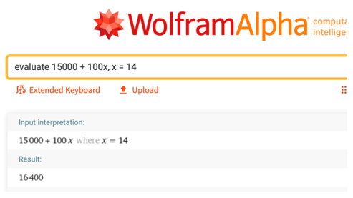

To evaluate $15,000+100x$ at x = 14 through 18, use the “table” command. Enter table 15000 + 100x, x = 14.. 18 in the entry field. Wolframalpha tells you what it thinks you entered, then tells you its answer. In this case it shows you a table with answers for $15000 + 100x, x = 14..18$.

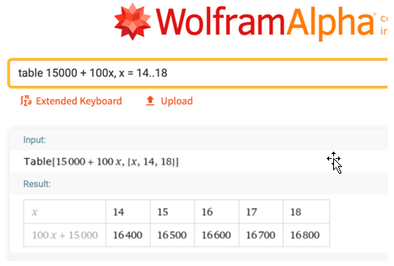­­

## EXAMPLES

Suppose a subscription to a photograph service costs $50/year and that each photograph downloads costs $2.

* 1. Which of the two quantities is the variable quantity?
  2. Which of the two quantities is the constant?
  3. Write the expression that produces the annual cost of subscribing and downloading $x$ number of photographs.
  4. What is the annual cost of subscribing and downloading 20 photographs?

Hotels often have mandatory *resort fees* or *destination fees*. These fees are not included in the advertised room rate and can deceive customers by making the hotel appear less expensive than it is. Hotels can advertise low room rates to fill rooms, but the resort fee act as a base price. Suppose during July, a Las Vegas hotel advertises a Sunday-Thursday daily room rate of $135. The fine print notes that the hotel charges a daily resort fee of $35.

* 1. Which of the two quantities is the variable quantity?
  2. Which of the two quantities is the constant?
  3. Write the expression that produces the cost of a room for one or more of the days Sunday-Thursday. Chose any letter you like to represent the variable quantity.
  4. What is the cost of staying in this hotel Tuesday, Wednesday, and Thursday nights?

What is the minimum number of cookies a person must eat to be happy? What is the minimum number of cookies beyond that number must eat to feel sick? These numbers are likely different for all of us. Let the variable $x$ represent the minimum number of cookies someone must eat to be happy, and the variable $y$ be the minimum number that makes that person sick.

* 1. How many variable quantities are in this problem?
  2. Are there any constants in this problem?
  3. Write an expression that produces the minimum number of cookies one must eat to feel sick.

## NOTE TO INSTRUCTOR

Consider showing this on the board. You can use it to discuss the meanings of the terms constants, variables, and expressions.

To produce a textbook, suppose the publisher spent $140,000 for typesetting and $5.50 per book for printing and binding.

* + 1. Which of the two quantities is the variable quantity?
    2. Which of the two quantities is the constant?
    3. Write the expression that produces the cost of producing $x$ number of books.
    4. What is the cost of producing 1000 books?
    5. What is the cost of producing the 1001st book?

ANSWERS:

1. The variable is the number of textbooks to be printed and bound.
2. The constant is $140,000 for typesetting.
3. The expression that produces the cost of producing $x$ number of books is

$5.50 $x$ + 140,000.

1. The cost of producing 1000 books is $5.50*(1000) + 140,000 = $145,500.
2. The cost of producing the 1001st books is

(The cost of producing 1001 books) – (The cost of producing 1000 books)

= ($5.50*(1001) + 140,000) – $145,500

= $145,505.50 – $145,500

= $5.5

[1-1_constants_variables_and_expressions.docx](https://oer4cte.org/math4gamedevelopers/teacher/1-1_constants_variables_and_expressions.docx), attributed to Denny Burzynski (author) and Downey Unified School District (publisher) is licensed under CC BY-NC 4.0. To view a copy of this license, visit https://creativecommons.org/licenses/by-nc/4.0